Validation of ontologies using UTAUT
The goal of this questionnaire is to validate the ontologies and to get a better understanding of the acceptance of the proposed semantic web technology. The responses to this questionnaire are anonymous. The questions are based on the Unified theory of acceptance use of technology (UTAUT) model and after each determinant there are questions regarding your feedback.
The completion of this survey is estimated to take approximately 15 minutes.
I would like to thank you for your participation and collaboration!

Could you indicate what is your current position?
______________________________________________________________________________

The next questions will be towards the determinant: "Performance Expectancy".
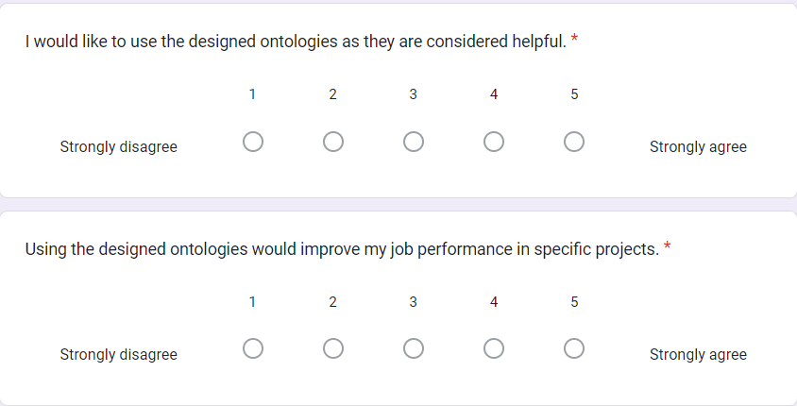
Could you please elaborate on your reasoning about the above questions which indicate the "Performance Expectancy" of the ontology? (i.e., why do you give these scores? Where and when can you use it?)
_______________________________________________________________________________
_______________________________________________________________________________
_______________________________________________________________________________
_______________________________________________________________________________
_______________________________________________________________________________

The next questions will be towards the determinant: "Effort Expectancy".
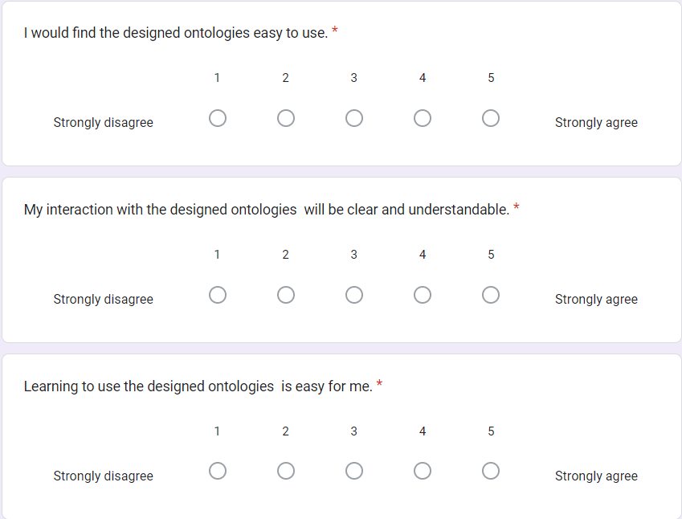
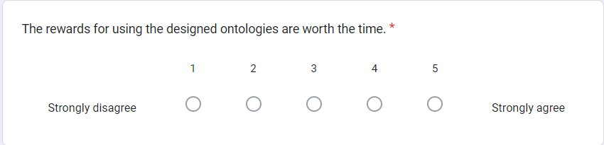
Could you please elaborate on your reasoning about the above questions which indicate the "Effort Expectancy" of the ontologies? (i.e., why do you give these scores? Why or why not do you find it easy to use, what rewards could you mention? etc.)
_______________________________________________________________________________
_______________________________________________________________________________
_______________________________________________________________________________
_______________________________________________________________________________
_______________________________________________________________________________

The next questions will be towards the determinant: "Attitude Towards" Technology.
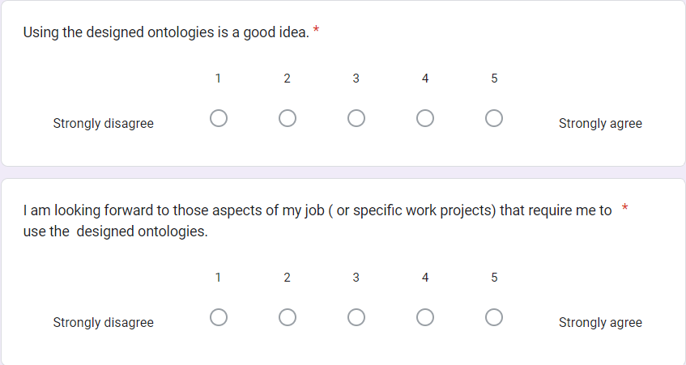
Could you please elaborate on your reasoning about the above questions which indicate the "Attitude Towards Technology" determinant? (i.e., why do you give these scores? Why or why not the usage of these ontologies is a good idea, etc.)
_______________________________________________________________________________
_______________________________________________________________________________
_______________________________________________________________________________
_______________________________________________________________________________
_______________________________________________________________________________

The next questions will be towards the determinant: "Facilitating Conditions".
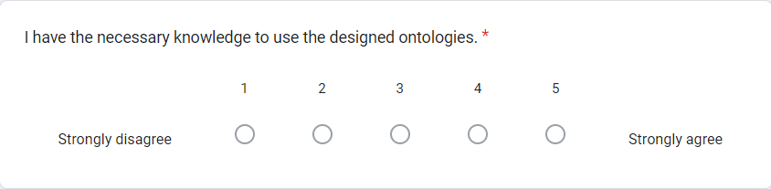
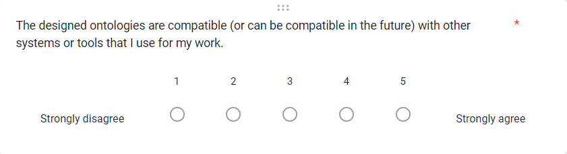
Could you please elaborate on your reasoning about the above questions which indicate the "Facilitating Conditions" determinant? (i.e., why do you give these scores? if you find these ontologies compatible with other tools that you are currently using or will use in the future, could you please mention which tools? Etc.)
_______________________________________________________________________________
_______________________________________________________________________________
_______________________________________________________________________________
_______________________________________________________________________________
_______________________________________________________________________________

The next questions will be towards the determinant: ''Self-Efficacy".
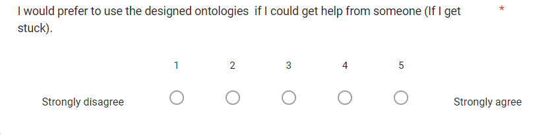
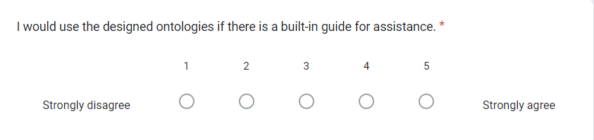
Could you please elaborate on your reasoning about the above questions which indicate the "Self-Efficacy" determinant? i.e., why do you give these scores? What kind of help would you need from someone else? Etc.)
_______________________________________________________________________________
_______________________________________________________________________________
_______________________________________________________________________________

The next questions will be towards the determinant: "Behavioral Intention of Use".
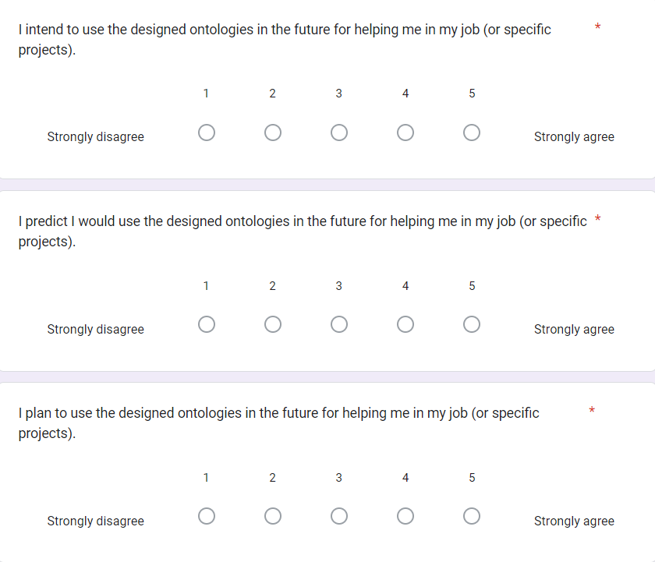
Could you please elaborate on your reasoning about the above questions which indicate the "Behavioral Intention of Use" determinant? (i.e., why do you give these scores? etc.)
_______________________________________________________________________________
_______________________________________________________________________________
_______________________________________________________________________________
_______________________________________________________________________________
_______________________________________________________________________________

The next questions will be towards the determinant: "Anxiety".
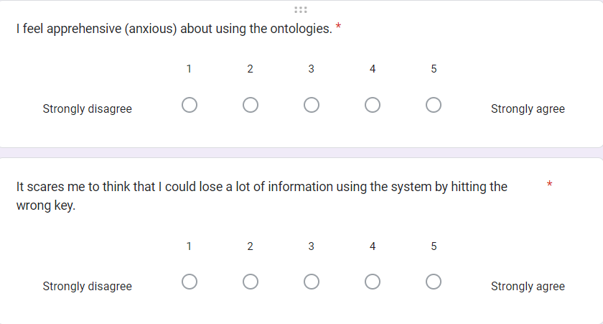
Could you please elaborate on your reasoning about the above questions which indicate the "Anxiety" determinant? (i.e., why do you give these scores? etc.)
_______________________________________________________________________________
_______________________________________________________________________________
_______________________________________________________________________________
_______________________________________________________________________________
_______________________________________________________________________________
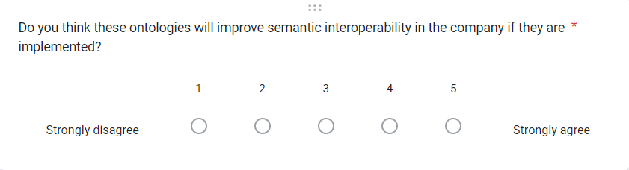
Could you please elaborate on your reasoning about the above question: why do you think it will improve semantic interoperability or why not?
_______________________________________________________________________________
_______________________________________________________________________________
_______________________________________________________________________________
_______________________________________________________________________________
Please provide any additional feedback that you might have.
_______________________________________________________________________________
_______________________________________________________________________________
_______________________________________________________________________________

Thank you very much for your feedback and participation!

